Programmed I/O, Interrupt & Direct Memory Access (DMA)
Programmed I/O
Programmed I/O (PIO) refers to data transfers initiated by a CPU under driver software control to access registers or memory on a device.
The CPU issues a command then waits for I/O operations to be complete. As the CPU is faster than the I/O module, the problem with programmed I/O is that the CPU has to wait a long time for the I/O module of concern to be ready for either reception or transmission of data. The CPU, while waiting, must repeatedly check the status of the I/O module, and this process is known as Polling. As a result, the level of the performance of the entire system is severely degraded.
Programmed I/O basically works in these ways:
- CPU requests I/O operation
- I/O module performs operation
- I/O module sets status bits
- CPU checks status bits periodically
- I/O module does not inform CPU directly
- I/O module does not interrupt CPU
- CPU may wait or come back later
Interrupt
The CPU issues commands to the I/O module then proceeds with its normal work until interrupted by I/O device on completion of its work.
For input, the device interrupts the CPU when new data has arrived and is ready to be retrieved by the system processor. The actual actions to perform depend on whether the device uses I/O ports, memory mapping.
For output, the device delivers an interrupt either when it is ready to accept new data or to acknowledge a successful data transfer. Memory-mapped and DMA-capable devices usually generate interrupts to tell the system they are done with the buffer.
Although Interrupt relieves the CPU of having to wait for the devices, but it is still inefficient in data transfer of large amount because the CPU has to transfer the data word by word between I/O module and memory.
Below are the basic operations of Interrupt:
- CPU issues read command
- I/O module gets data from peripheral whilst CPU does other work
- I/O module interrupts CPU
- CPU requests data
- I/O module transfers data
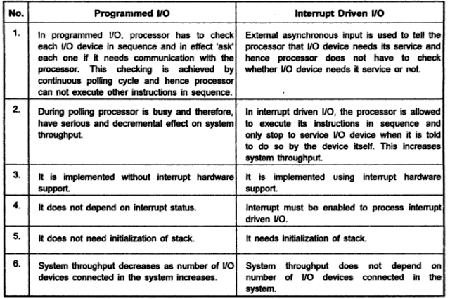

Direct Memory Access (DMA)
Direct Memory Access (DMA) means CPU grants I/O module authority to read from or write to memory without involvement. DMA module controls exchange of data between main memory and the I/O device. Because of DMA device can transfer data directly to and from memory, rather than using the CPU as an intermediary, and can thus relieve congestion on the bus. CPU is only involved at the beginning and end of the transfer and interrupted only after entire block has been transferred.

Direct Memory Access needs a special hardware called DMA controller (DMAC) that manages the data transfers and arbitrates access to the system bus. The controllers are programmed with source and destination pointers (where to read/write the data), counters to track the number of transferred bytes, and settings, which includes I/O and memory types, interrupts and states for the CPU cycles.
DMA increases system concurrency by allowing the CPU to perform tasks while the DMA system transfers data via the system and memory busses. Hardware design is complicated because the DMA controller must be integrated into the system, and the system must allow the DMA controller to be a bus master. Cycle stealing may also be necessary to allow the CPU and DMA controller to share use of the memory bus.

